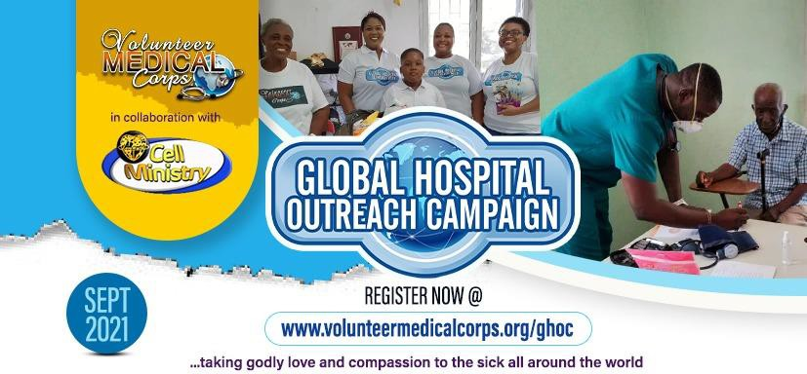

CHECKLIST TO PREPARE FOR 2021 GLOBAL HOSPITAL OUTREACH CAMPAIGN (GHOC)
CATEGORY | TASK | PERSONNEL | STATUS | COMMENTS
TEAM MAXIMISATION | Set up a GHOC Committee to ensure the success of the campaign led by the Zonal Pastor, Group Pastor and Church Pastor
Encourage VMC leaders, Cell leaders, BSCTs to attend all
review meetings.
 | Dispatch GHOC publicity materials and targets to all Cell Ministry Managers, Cell Leaders, BSCTs, and VMC leaders and members in the zone.
Organized Onsite/ Online meetings with all stakeholders
and secure their commitment
 | Identify the selected hospitals and health care facilities to be visited and pre-register them on the GHOC portal. www.volunteermedicalcorps.org/ghoc
PUBLICITY | Pulpit announcements by the Pastor at every service, prayer meetings and on leaders’ group.  b. Daily SMS and email dispatch to members and leaders to remind, enquire, motivate, and inspire them  d. Short videos to show the importance of GHOC  e. Purposeful and impactful talk-shows, drama skits, music to drive the inspiration.
Production of T-shirts and face caps using the approved designs.
Download the approved designs on www.volunteermedicalcorps.org/ghoc

Create a stand in church to provide
Information
 | Production of church Invitational cards
REGISTRATION | Selected and approved health facilities should be registered on the GHOC website www.volunteermedicalcorps.org/ghoc
GIFT MATERIALS | Healing to the Nations magazines, Healing from Heaven, Rhapsody of Realities
Mobilise brethren/team to put together gift items such
as food items, groceries, personal care items, medical supplies and cash gifts (optional) for those to be visited
 | Brand all the gift packages with GHOC logo stickers
REPORT SUBMISSION/MEDIA | All reports should be submitted the cell leader/Cell ministry manager on the GHOC report portal  www.volunteermedicalcorps.org/ghoc or via mail to vmedcorps@gmail.com
All GHOC pictures should be posted on the zonal Superuser on Kingschat using the hashtags:
#ghoc
#lwcellministry
#yourzone
#yourcountry

MEDIA SCRIPT/CHECKLIST FOR GHOC VIDEO CAMERA RECORDINGS AND STILL PHOTOGRAPHY *** HD quality preferred.
1. | Video recording/still pictures of the publicity materials, banners, fliers, and billboards if any  Signage of the hospital/ orphanage /old people’s home/venue of the outreach  Front view of the hospital/ orphanage / old people’s home visited
2. | Video recording/still pictures of the facility (with permission from the management)
3. | Video recording/still pictures of inflow of people and health workers /staff attending to people
4. | Video recording/still pictures of the hospital wards, the outreach Centre, the location of the event
5. | Video recording/still pictures of GHOC team as they minister to the people present  Always remember to obtain their verbal /written consent  - Presentation of the gifts to a representative of the Management of the facility prior to its distribution to the residents, pictures of the medical equipment, drugs, and surgical equipment etc.
 | - Hospital staff, recipients (patients, relatives etc.) holding the magazines and ministry materials - GHOC team praying for the sick and handing out the relief materials, providing care to them, cleaning the facility etc.
8. | Video recording/still pictures of host pastor or GHOC team leader ministering the word to the sick
9. | Shots of new converts
10. | Group photograph of GHOC members and hospital staff or management of the location of the event or program beneficiaries
11. | Group picture of the GHOC Team with the ministry materials and their gifts and relief materials
13. | Interviews of participants  My Experience as a Volunteer for the GHOC Campaign (team leaders, members speak of their motivation and the actual experience)  My experience of the outreach by 2-3 beneficiaries
14. | After program interview with VMC/ team leader-he/ she should talk about the reason behind the outreach and extend appreciation to the Man of God Pastor Chris Oyakhilome, Healing School, the Loveworld Cell Ministry, the Loveworld Medical Missions, their Church, their Pastor/Organization and the Volunteer Medical Corps.

